



Submitted by: Madan Lal

Instructor: Dr. Faheem Akhtar Rajput

**LAB # 02**

Sukkur IBA University, Nisar Ahmed Siddique Road, Sukkur

CMS ID: 053-18-0005

**Department of Computer Science**

Semester VI

**SIBAU**

**JAVA**

**Lab Tasks**

**Exercises**

1. Write a Java program to concatenate a given string to the end of another string

class Lab2

{

    public static void main(String args[])

    {

        String Firstname = "Madan";

        String LastName = "Lal";

        System.out.println(Firstname.concat(LastName));

    }

}

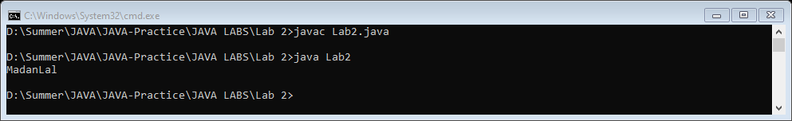

1. Write a program that computes your initials from your full name and displays them.

class Lab2

{

    public static void main(String args[])

    {

        String Fullname = "Madan Lal Lal";

        String[] str = Fullname.split(" ",0);

                for(String a : str)

                {

                    System.out.println(a.charAt(0));

                }

    }

}

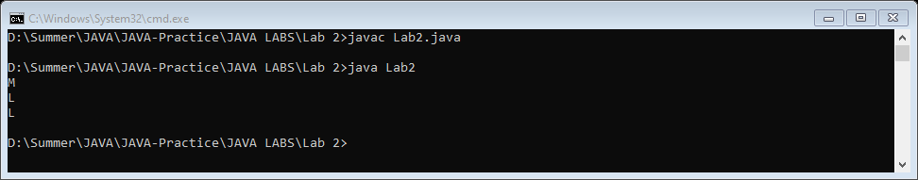

1. Write a Java program to replace each substring of below given sample string
   1. Sample string : "The quick brown fox jumps over the lazy dog."
   2. In the above string replace all the fox with cat

class Lab2

{

    public static void main(String args[])

    {

        String Sample = "The quick brown fox jumps over the lazy dog.";

        Sample = Sample.replace("fox","cat");

        System.out.print(Sample);

    }

}

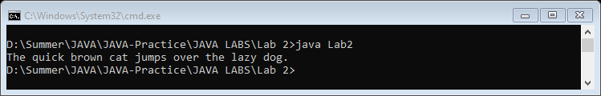

1. Write a program to print a table of all prime numbers less than 600, take the first 600 integers and cross out all those that are multiples of 2, 3, 5, etc. until only primes remain, then print out the table.

class Lab2

{

    public static void main(String args[])

    {

        int count = 2;

        while(count != 600)

        {

            boolean flag = true;

            for(int i=2; i<count; i++)

            {

                if(count%i == 0)

                {

                    flag=false;

                }

            }

            if(flag)

            {

                for(int j=1; j<=10; j++)

                    {

                        System.out.println(j +" x "+ count + " = " + count*j);

                    }

            }

            count++;

        }

    }

}

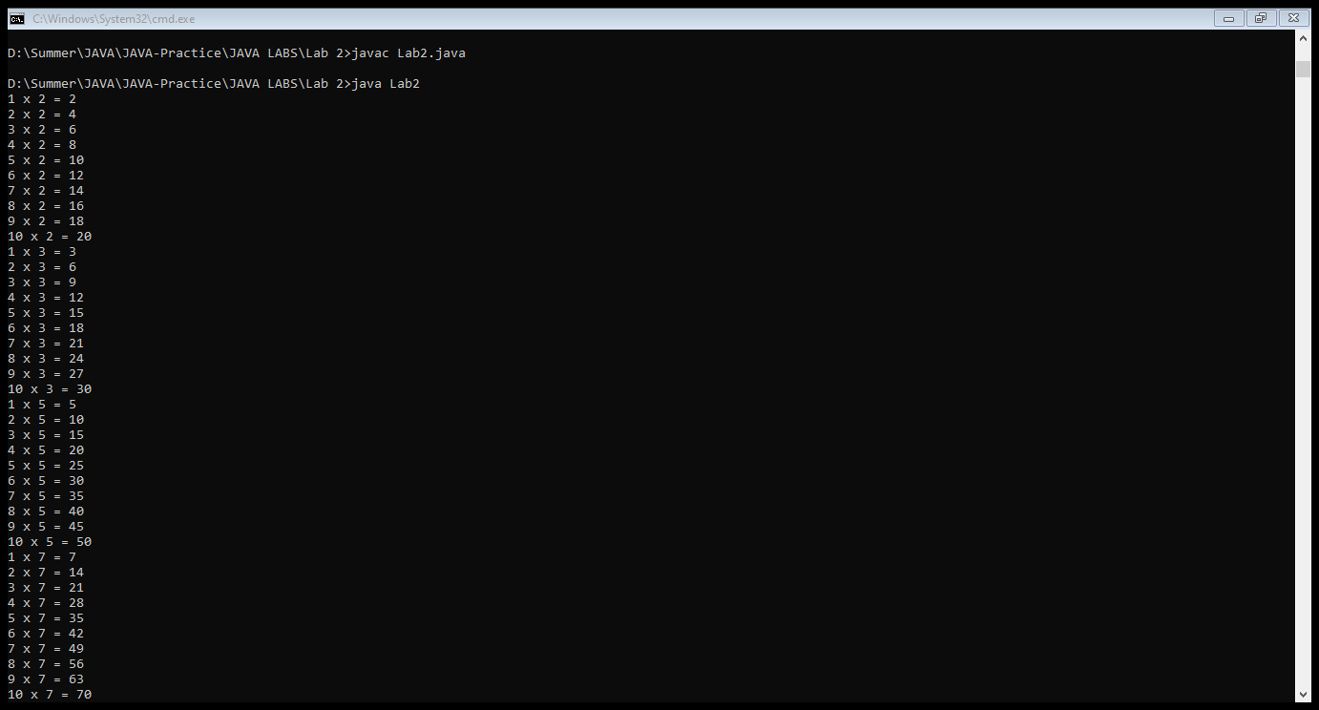

Upto 599

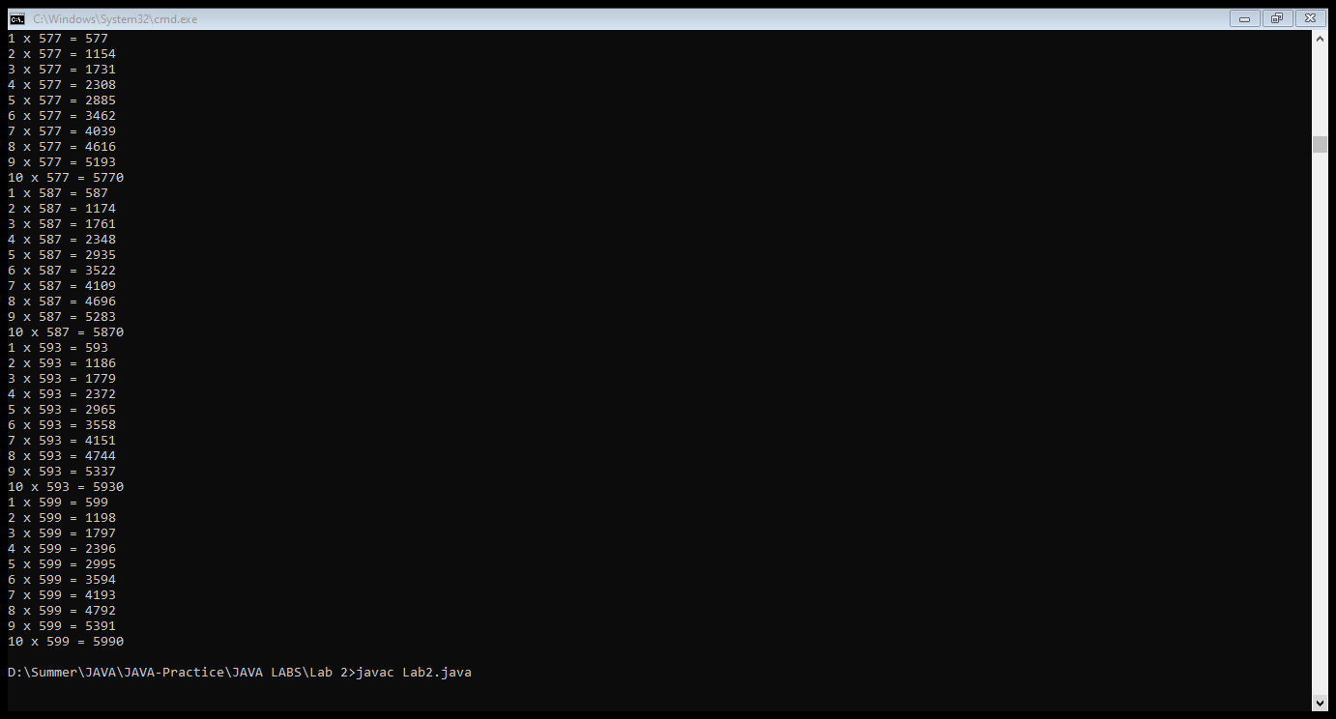

1. Write a program which solves quadratic equations of the form: ax2 + bx + c = 0. Values of a, b, c and x can be taken as input from user.

import java.util.Scanner;

class Lab2

{

    public static void main(String args[])

    {

        Scanner input = new Scanner(System.in);

        System.out.print("Enter value of a : ");

        int a = input.nextInt();

        System.out.print("Enter value of b : ");

        int b = input.nextInt();

        System.out.print("Enter value of c : ");

        int c = input.nextInt();

        System.out.print("Enter value of x : ");

        int x = input.nextInt();

        int solution = (a*x*x)+(b*x)+c;

        System.out.println("Quardatic equation solution is : "+solution);

    }

}

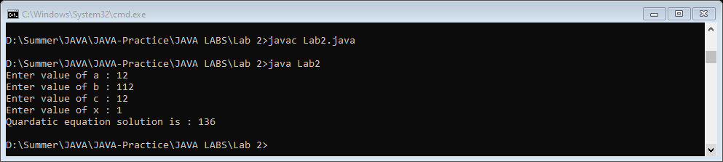

1. Write code that creates an array named odds and stores all odd numbers between 1 and 30 into it using a for loop.

class Lab2

{

    public static void main(String args[])

    {

        int[] odds = new int[15];

        int count =0;

        for(int i=1; i<30; i++)

        {

            if(i%2 != 0)

            {

                odds[count++] = i;

                System.out.print(odds[count-1]+" ");

            }

        }

    }

}

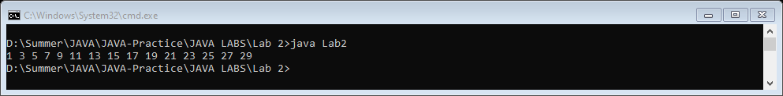

1. Write a Java program to round up the result of integer division

import java.util.Scanner;

class Lab2

{

    public static void main(String args[])

    {

        Scanner input = new Scanner(System.in);

        System.out.print("Enter First Number : ");

        int num1 = input.nextInt();

        System.out.print("Enter Second Number : ");

        int num2 = input.nextInt();

        float division = (float)num1/(float)num2;

        System.out.println("Integer division Round Up Result : "+Math.round(division));

    }

}

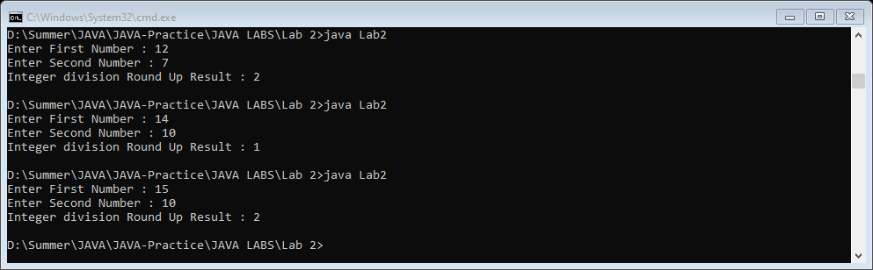

**End of Lab 2**